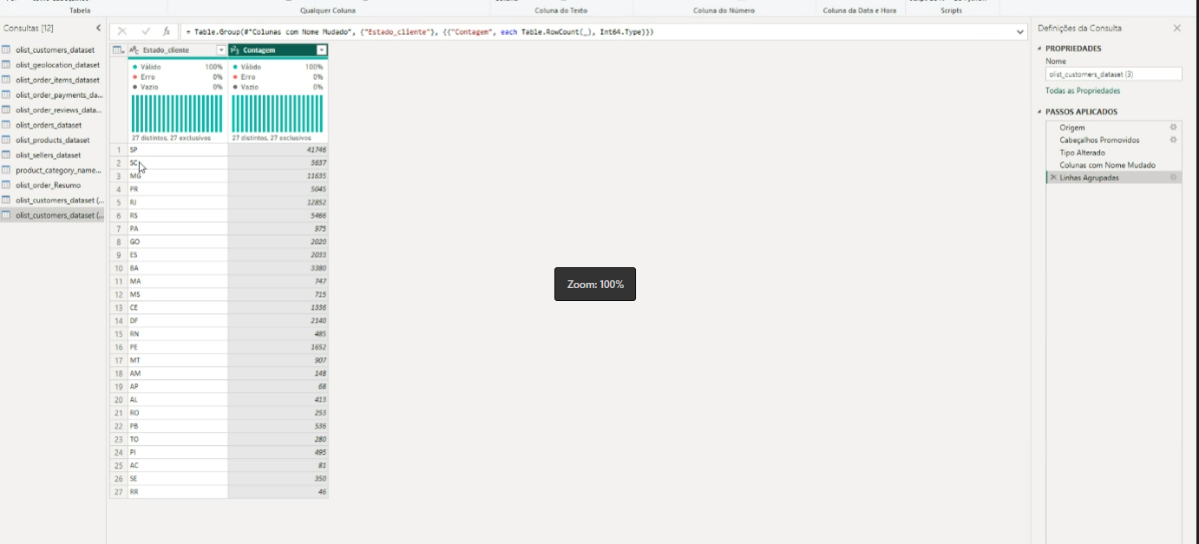

58,9 + 13,29 – valor do pagamento

